Bank Loan Database

- Project Overview
This project analyzes a real-world financial loan dataset to evaluate the health and performance of a bank’s lending portfolio. Using Python for exploratory data analysis, SQL for deep-dive querying, and Tableau for interactive visualization, I explored key questions such as:
- What percentage of loans are “Good” (Fully Paid / Current) vs. “Bad” (Charged Off)?
- What has been the loan trend over the past year? (Month, State, Term, Length of Employment, Purpose, Homeownership)
- What is the demographic and occupational profile of borrowers who most frequently default? (based on length of employment, loan purpose, and city)?
- Which loan term (36 vs. 60 months) is more prone to default?
The goal is to transform raw transactional data into actionable business insights that support risk management, underwriting strategy, and customer segmentation — all while practicing end-to-end data analytics workflow as a learning analyst

- Dataset Summary
- File:
- Source:
- Rows : 38576
- Coloumns: 24
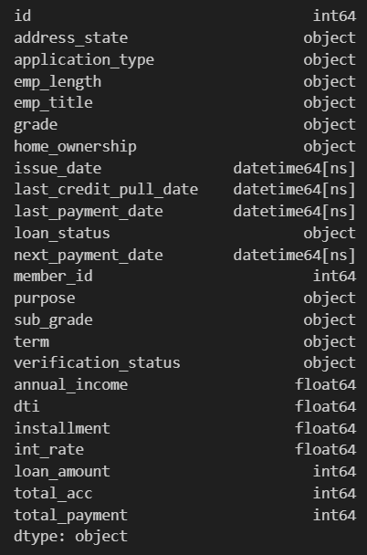
- Key Performance Indicators (KPIs) Requirements:
- Total Loan Applications count('id')
We need to calculate the total number of loan applications received during a specified period. Additionally, it is essential to monitor the Month-to-Date (MTD) Loan Applications and track changes Month-over-Month (MoM).

- Total Funded Amount sum('loan_amount')
Understanding the total amount of funds disbursed as loans is crucial. We also want to keep an eye on the Month-to-Date (MTD) Total Funded Amount and analyse the Month-over-Month (MoM) changes in this metric.
- Total Amount Received sum('total_payment’)
Tracking the total amount received from borrowers is essential for assessing the bank's cash flow and loan repayment. We should analyse the Month-to-Date (MTD) Total Amount Received and observe the Month-over-Month (MoM) changes.
- Average Interest Rate mean('int_rate’)
Calculating the average interest rate across all loans, MTD, and monitoring the Month-over-Month (MoM) variations in interest rates will provide insights into our lending portfolio's overall cost.
- Average Debt-to-Income mean('dti’)
Evaluating the average DTI for our borrowers helps us gauge their financial health. We need to compute the average DTI for all loans, MTD, and track Month-over-Month (MoM) fluctuations.

- Good Loan vs Bad Loan KPIs
- Good Loan KPIs
- Good Loan Application Percentage
We need to calculate the percentage of loan applications classified as 'Good Loans.' This category includes loans with a loan status of 'Fully Paid' and 'Current.'
- Good Loan Applications
Identifying the total number of loan applications falling under the 'Good Loan' category, which consists of loans with a loan status of 'Fully Paid' and 'Current.'
- Good Loan Funded Amount
Determining the total amount of funds disbursed as 'Good Loans.' This includes the principal amounts of loans with a loan status of 'Fully Paid' and 'Current.
- Good Loan Total Received Amount
Tracking the total amount received from borrowers for 'Good Loans,' which encompasses all payments made on loans with a loan status of 'Fully Paid' and 'Current.'

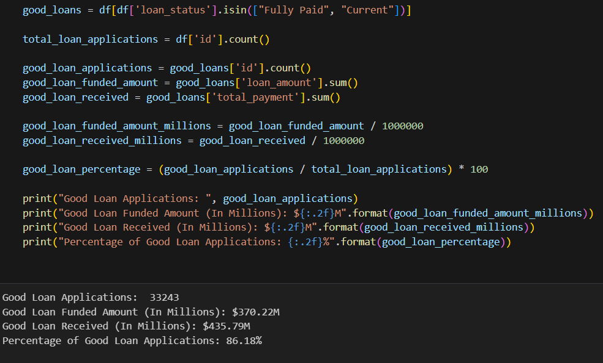

- Bad Loan KPIs
- Bad Loan Application Percentage
Calculating the percentage of loan applications categorized as 'Bad Loans.' This category specifically includes loans with a loan status of 'Charged Off.'
- Bad Loan Applications
Identifying the total number of loan applications categorized as 'Bad Loans,' which consists of loans with a loan status of 'Charged Off.'
- Bad Loan Funded Amount
Determining the total amount of funds disbursed as 'Bad Loans.' This comprises the principal amounts of loans with a loan status of 'Charged Off.'
- Bad Loan Total Received Amount
Tracking the total amount received from borrowers for 'Bad Loans,' which includes all payments made on loans with a loan status of 'Charged Off.'
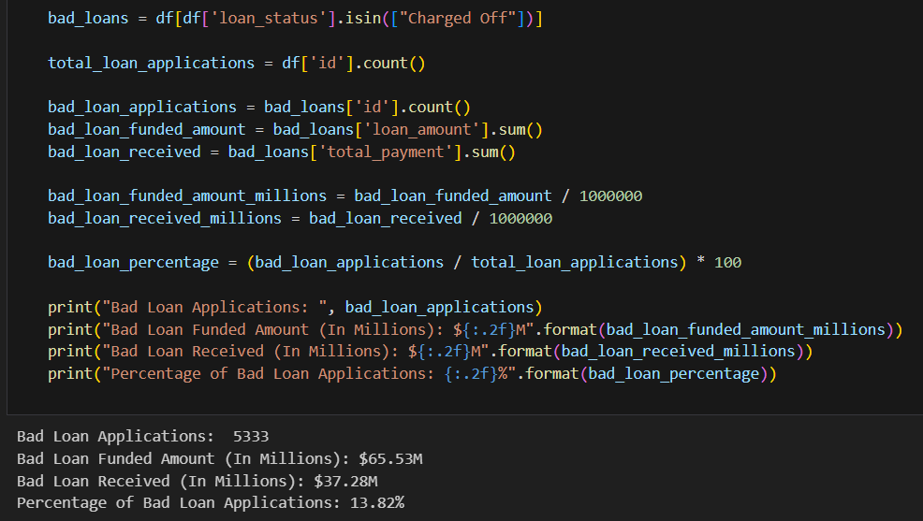
- Data Analysis Using Python
- Loaded pizza_sales.csv into a panda DataFrame
- Checked data shape, data types, missing values, and duplicates
- Calculated core KPIs:
- Visualized chart distributions :
- Monthly Trends by Issue Date (Line Chart)
This line chart will showcase how 'Total Loan Applications,' 'Total Funded Amount,' and 'Total Amount Received' vary over time, allowing us to identify seasonality and long-term trends in lending activities.
Chart Type: Line Chart
Metrics: 'Total Loan Applications,' 'Total Funded Amount,' and 'Total Amount Received'
X-Axis: Month (based on 'Issue Date')
Y-Axis: Metrics' Values
- Regional Analysis by State (Filled Map)
This filled map will visually represent lending metrics categorized by state, enabling us to identify regions with significant lending activity and assess regional disparities.
Chart Type: Filled Map
Metrics: 'Total Loan Applications,' 'Total Funded Amount,' and 'Total Amount Received'
Geographic Regions: States
- Loan Term Analysis (Donut Chart)
This donut chart will depict loan statistics based on different loan terms, allowing us to understand the distribution of loans across various term lengths.
Chart Type: Donut Chart
Metrics: 'Total Loan Applications,' 'Total Funded Amount,' and 'Total Amount Received'
Segments: Loan Terms (e.g., 36 months, 60 months)
- Employee Length Analysis (Bar Chart)
This bar chart will illustrate how lending metrics are distributed among borrowers with different employment lengths, helping us assess the impact of employment history on loan applications.
Chart Type: Bar Chart
Metrics: 'Total Loan Applications,' 'Total Funded Amount,' and 'Total Amount Received'
X-Axis: Employee Length Categories (e.g., 1 year, 5 years, 10+ years)
Y-Axis: Metrics' Values
- Loan Purpose Breakdown (Bar Chart)
This bar chart will provide a visual breakdown of loan metrics based on the stated purposes of loans, aiding in the understanding of the primary reasons borrowers seek financing.
Chart Type: Bar Chart
Metrics: 'Total Loan Applications,' 'Total Funded Amount,' and 'Total Amount Received'
X-Axis: Loan Purpose Categories (e.g., debt consolidation, credit card refinancing)
Y-Axis: Metrics' Values
- Home Ownership Analysis (Tree Map)
This tree map will display loan metrics categorized by different home ownership statuses, allowing for a hierarchical view of how home ownership impacts loan applications and disbursements.
Chart Type: Tree Map
Metrics: 'Total Loan Applications,' 'Total Funded Amount,' and 'Total Amount Received'
Hierarchy: Home Ownership Categories (e.g., own, rent, mortgage)
- Dashbord in Tableau
https://public.tableau.com/views/BankLoanDatabaseUS/SUMMARY?:language=en-GB&:sid=&:redirect=auth&:display_count=n&:origin=viz_share_link
Summary (Good Loan & Bad Loan Issued)
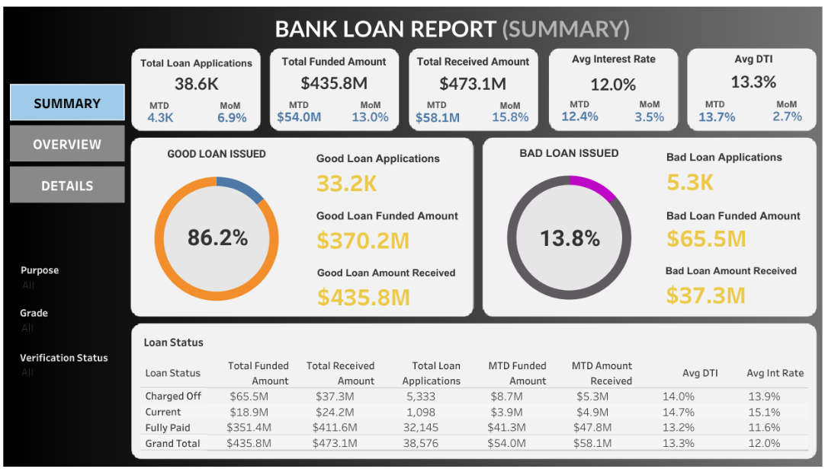
Overview (Total loan applications by month, state, term, employee length, purpose, and home own)
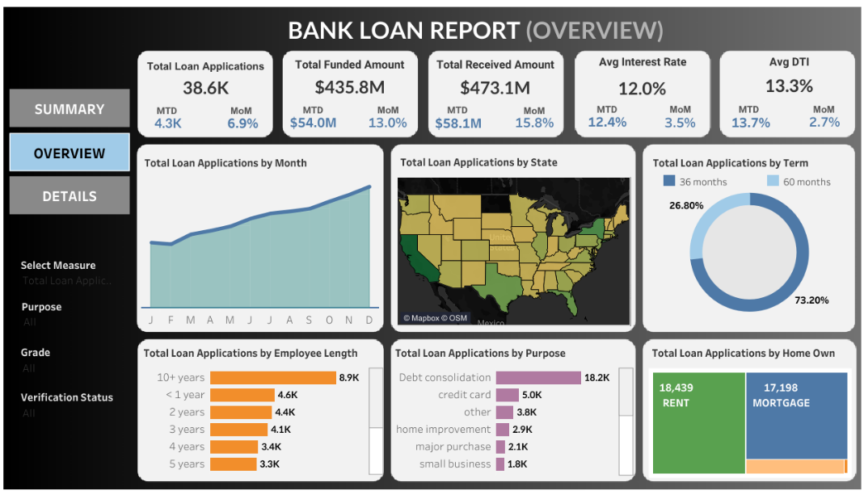
Details (detail information loan applications)
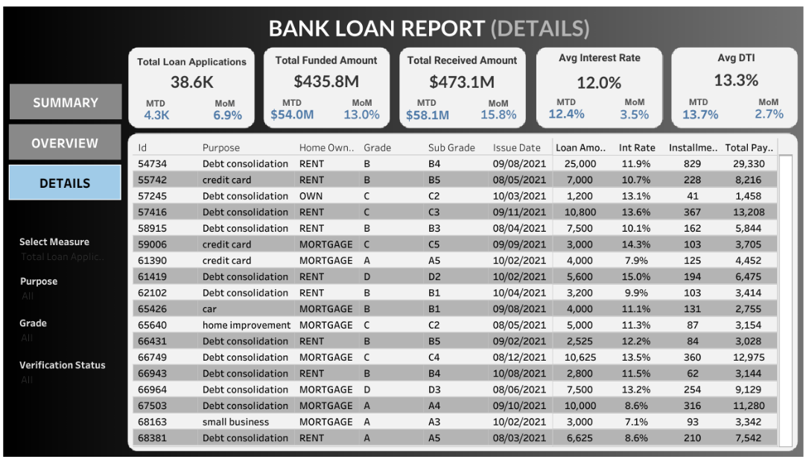

- Key Insight
Questions:
- What is the percentage of bad loan versus good loan?
- What has been the loan trend over the past year? (Month, State, Term, Length of Employment, Purpose, Homeownership)
- What is the demographic and occupational profile of borrowers who most frequently default? (based on length of employment, loan purpose, and city)?
- Which loan term (36 vs. 60 months) is more prone to default?
Insight
- 86.2% of all loans issued were "Good Loans" (Fully Paid/Current), while 13.8% were "Bad Loans" (Charged Off). More specifically, the total funds disbursed for Good Loans were $370.2 million, with $435.8 million refunded. This resulted in a profit of $65.6 million. Meanwhile, the total funds disbursed for bad loans were $65.5 million, with only $37.3 million refunded, resulting in a loss of $28.2 million. The total profit earned by the bank was $37.4 million.
- The loan trend increased consistently throughout the year, with significant changes at the end of the year. The graph showing Total Loan Applications per Month shows an upward trend from January to December. This could be due to seasonal factors (e.g., Christmas shopping, holidays, or year-end financial planning).
- The Total Loan Applications per Month shows an upward trend from January to December. This could be due to seasonal factors (e.g., Christmas shopping, holidays, or year-end financial planning).
- 73.2% of loans had a 60-month term, while only 26.8% chose 36 months. This indicates a preference for borrowers for lower installments despite higher total costs. Furthermore, loans with a 60-month term tend to be less prone to bad debt.
- Loans with a tenure of more than 10 years were the most frequently applied for (8.9,000), followed by loans with a tenure of less than 1 year (4.6,000). This is interesting—new lenders are also active, which could be a target market or risk segment.
- The dominant loan purpose was “Debt Consolidation” (18.2,000), followed by “Credit Card” (5.0,000). This suggests that most borrowers are seeking to settle their debt, rather than make major purchases.
- Borrowers who rent (18,439) slightly outnumber those who have a mortgage (17,198). This can be a risk factor because the lender who leases may have lower financial stability.
- States like CA, NY, FL, and TX account for >40% of total loans. However, the Charge-Off percentage in FL and TX is slightly higher than in CA/NY.

- Business Recommendations
- Risk Management & Underwriting
- Tighten criteria for borrowers with less than 1 year of employment and a “Not Verified” verification status, especially if their DTI is >20%.
- Limit the term to 60 months for “Debt Consolidation” loans, as this combination correlates with a higher risk of default.
- Require income verification (“Source Verified” or “Verified”) for loans over $10,000** from borrowers with a short employment history.
- Segmentation and Marketing
- Increase marketing allocation to states with stable performance (e.g., CA, NY, IL) and borrowers with **5 years of employment and a “MORTGAGE” status.
- Reduce aggressive offers to the “RENT + <1 year employment” segment unless they have special loan features (short term, low ceiling).
- Operational & Monitoring
- Establish an Early Warning System (EWS) based on two key variables:
- DTI > 20%
- Verification status = “Not Verified”
→ If both are met, the system automatically marks the application as “High Risk.”
- Product Diversifications
- Encourage loans for “Home Improvement,” “Medical,” or “Small Business” purposes through preferential interest rates — as data shows their default rates are lower than those for “Debt Consolidation.”

📝 Note to Recruiters
I’m a data analyst still learning, but I care deeply about clean code, business relevance, and clear communication.
This project reflects my ability to work independently through the full analytics lifecycle: data → insight → action.
Feedback is always welcome!
My reference:
YouTube: Data Tutorials

